**SPRING REST using SPRING BOOT 3 HANDSON**

**1.Hello World RESTful Web Service**

Write a REST service in the spring learn application created earlier, that returns the text "Hello World!!" using Spring Web Framework.

->Step-1:Updating application.properties (to change port to 8083)

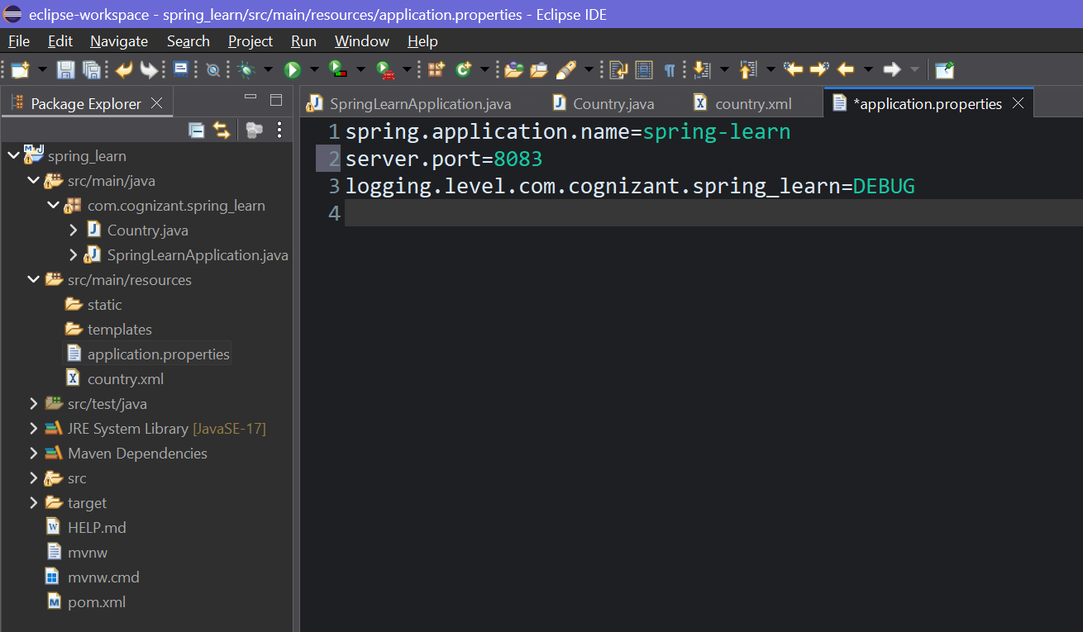

Step-2: Creating the Controller Package and Class and writing HelloController code in HelloController.java

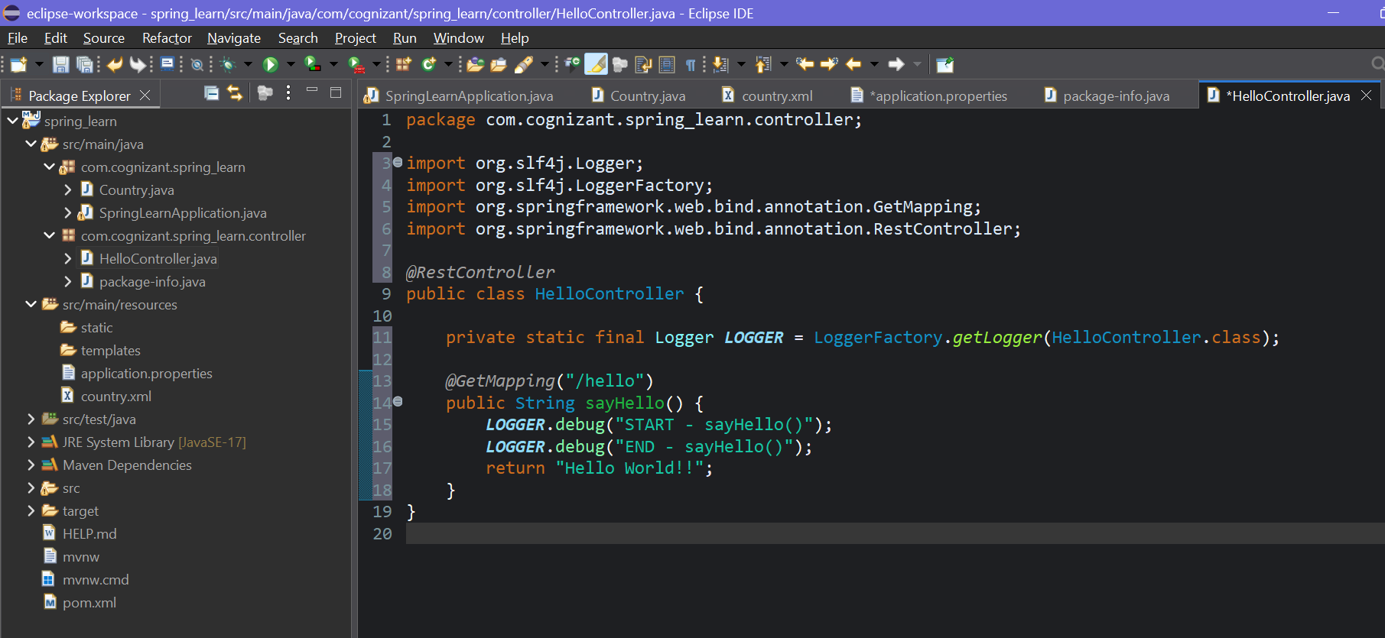

Step-3:Updating SpringLearnApplication.java

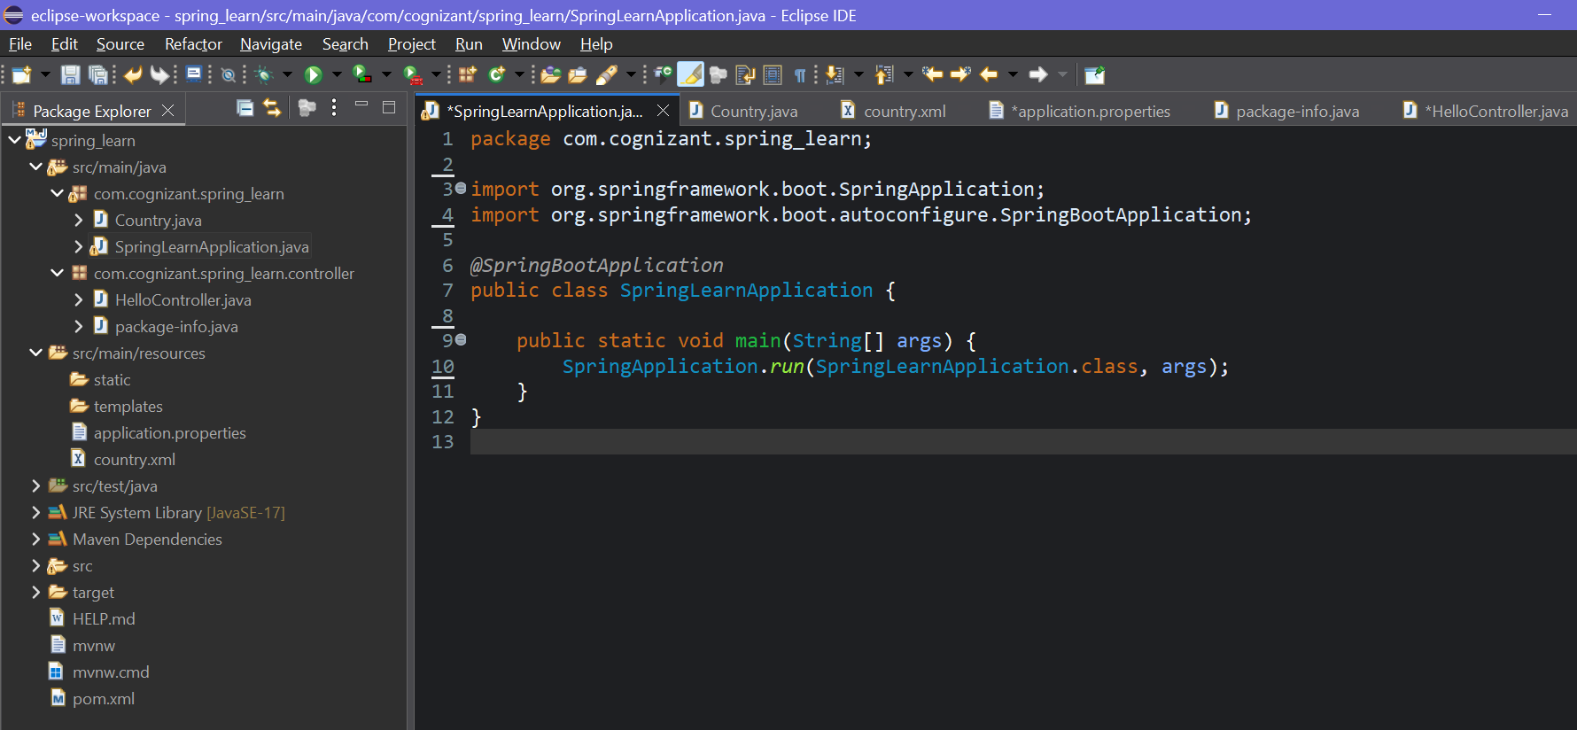

Step-4:Running the SpringLearnApplication.java

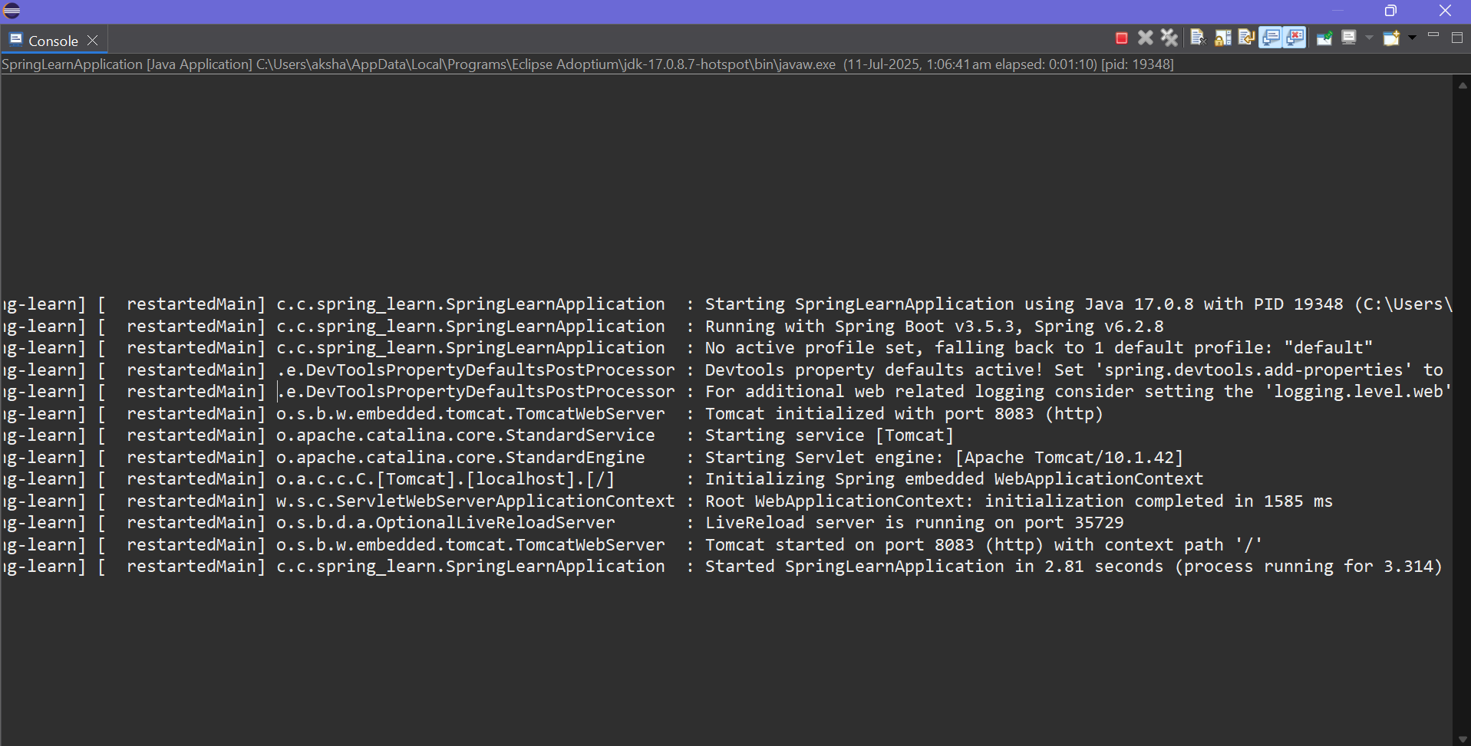

Step-5:Testing the API on postman

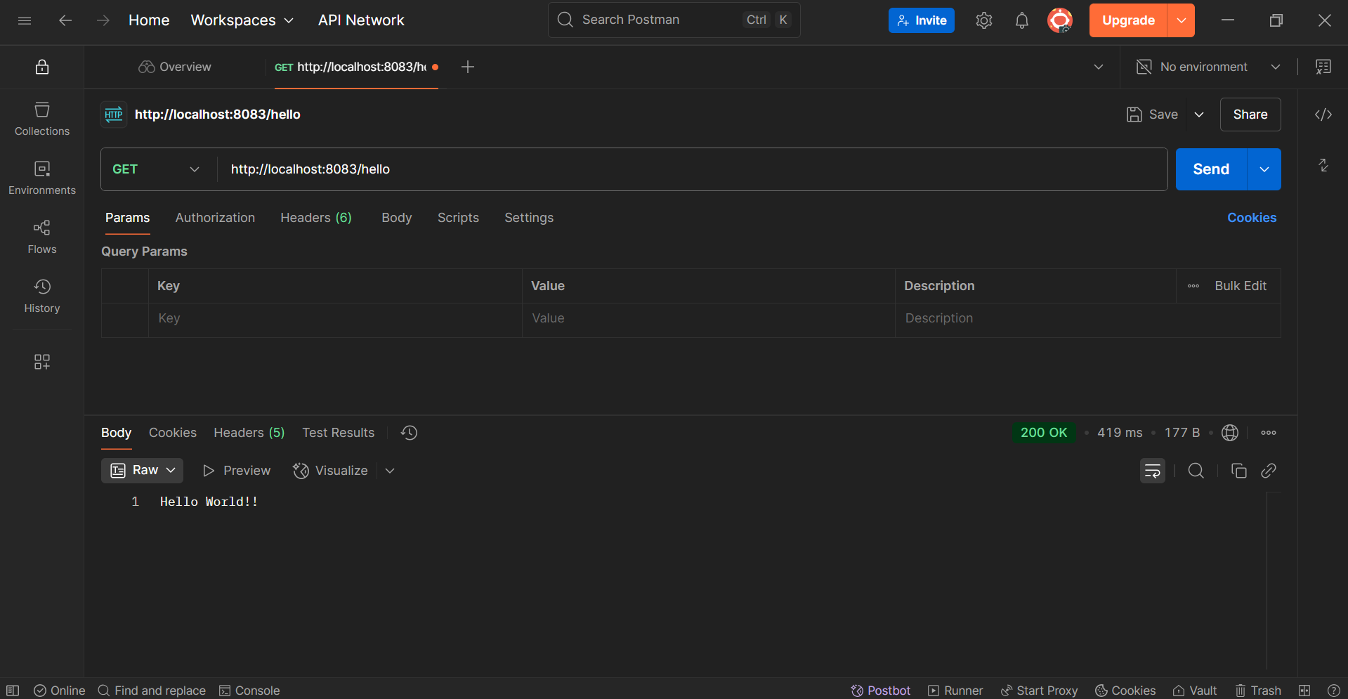

**2.REST - Country Web Service**   
Write a REST service that returns India country details in the earlier created spring learn application.

->Step-1:Project Setup-

We already have:

* Country class with code, name, constructors, getters, setters, toString()
* country.xml inside src/main/resources
* Spring Boot configured and running on port 8083

Step-2:Creating CountryController.java and updating the code

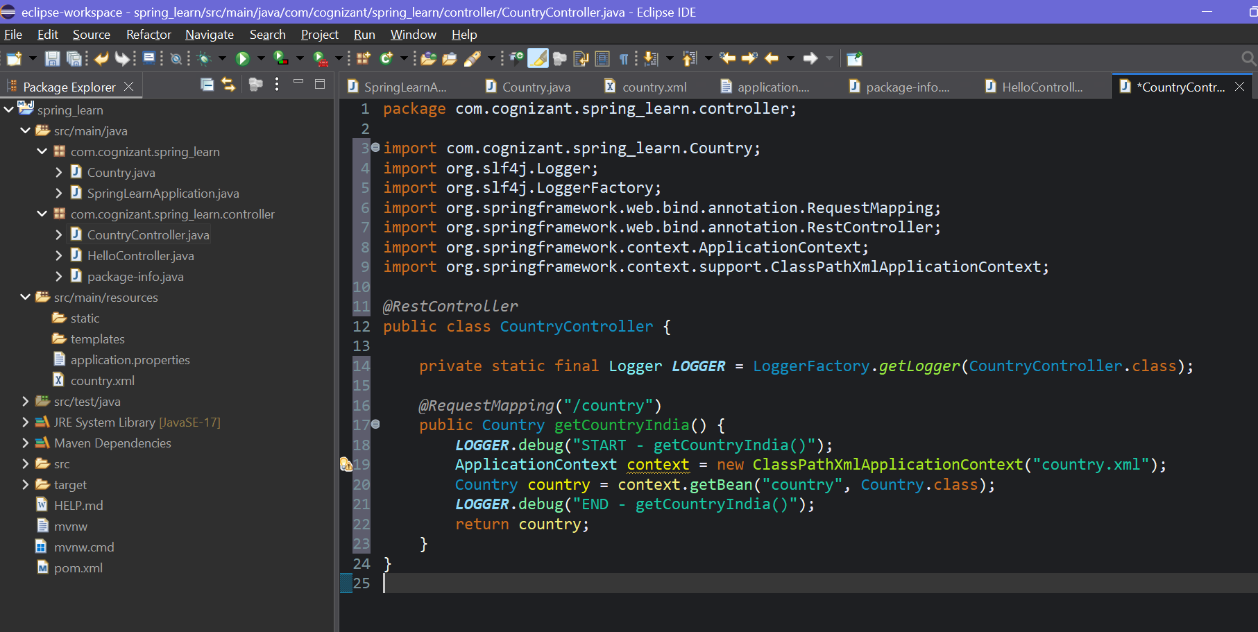

Step-3:Running the application

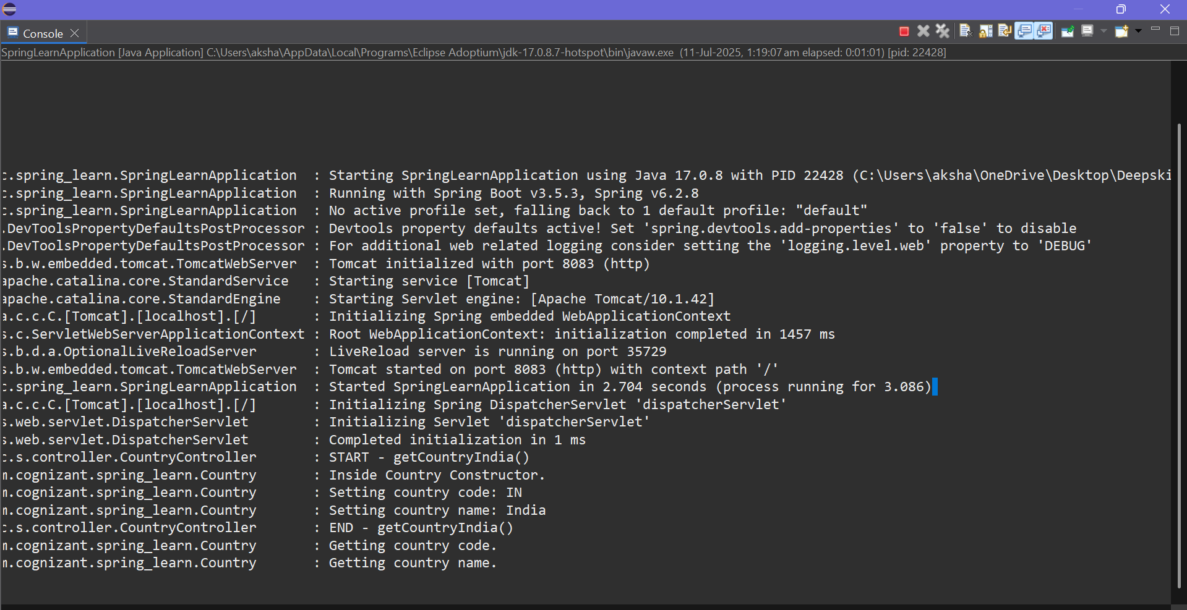

Step-4:Testing it in the Postman

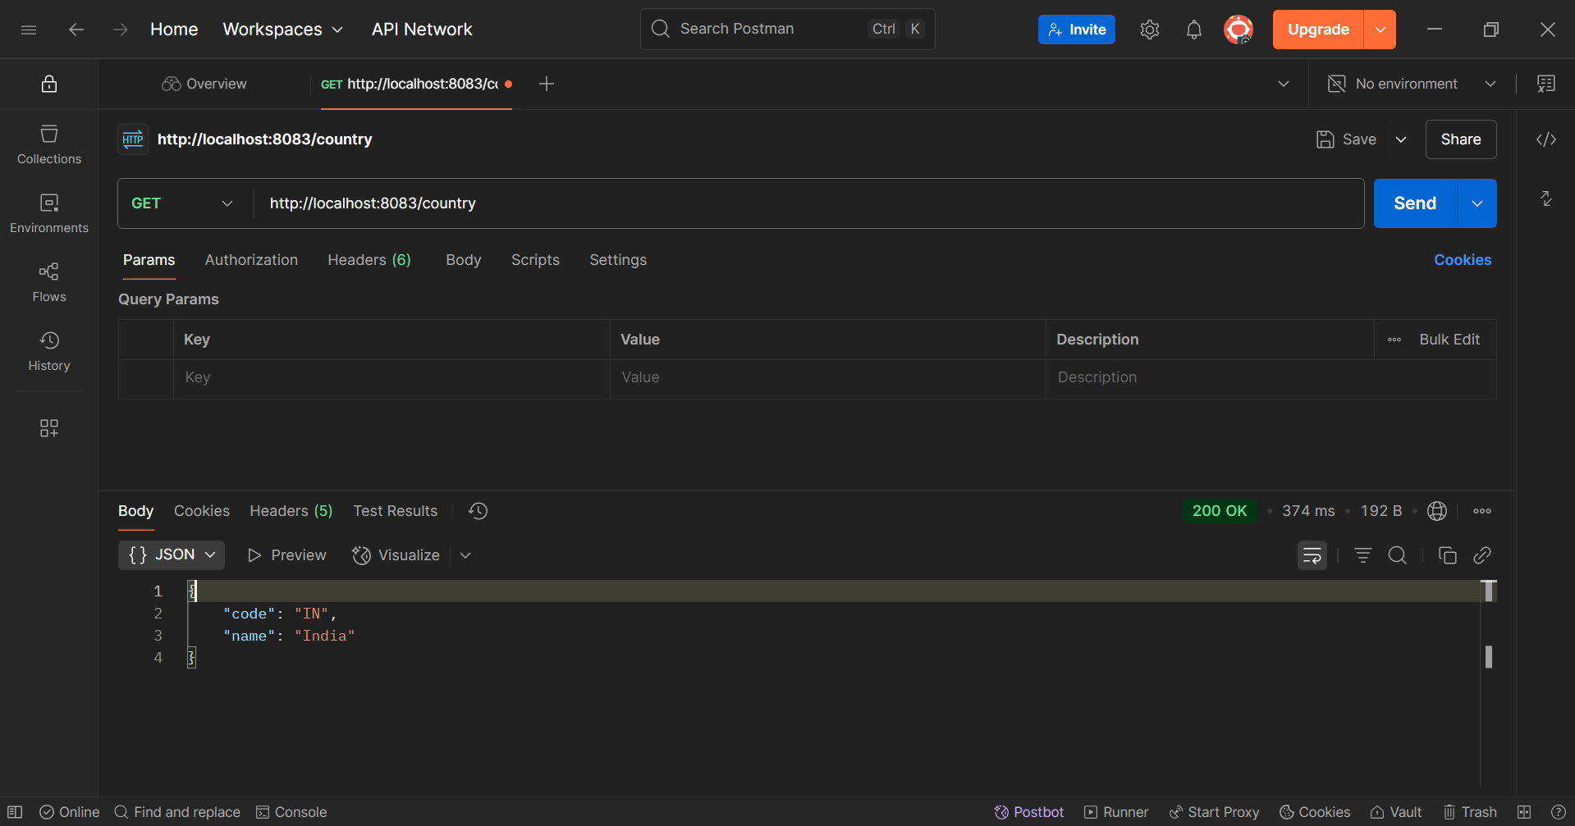

Step-5: Viewing HTTP Headers in Postman

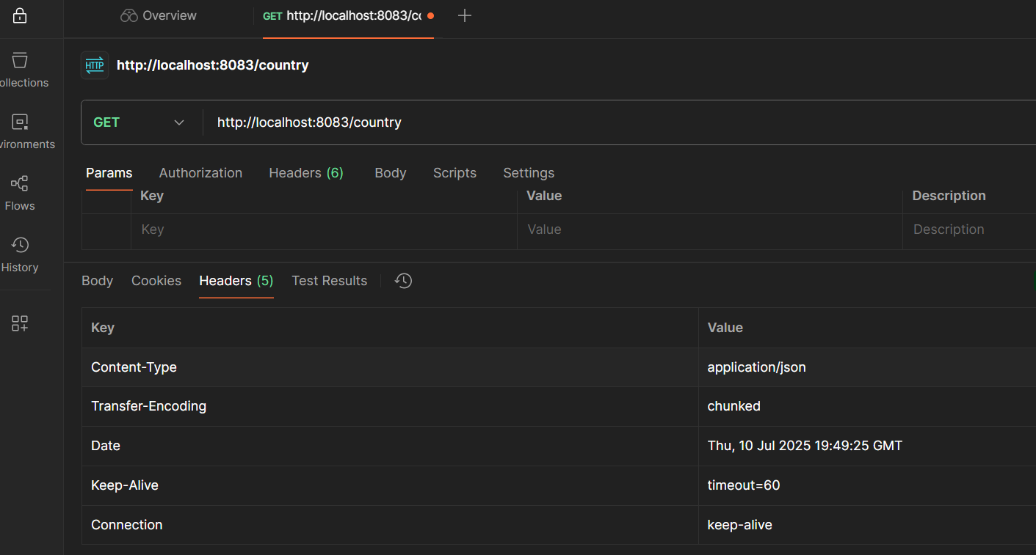

**3.REST - Country Web Service**   
Write a REST service that returns India country details in the earlier created spring learn application

->Step-1: Verifying country.xml

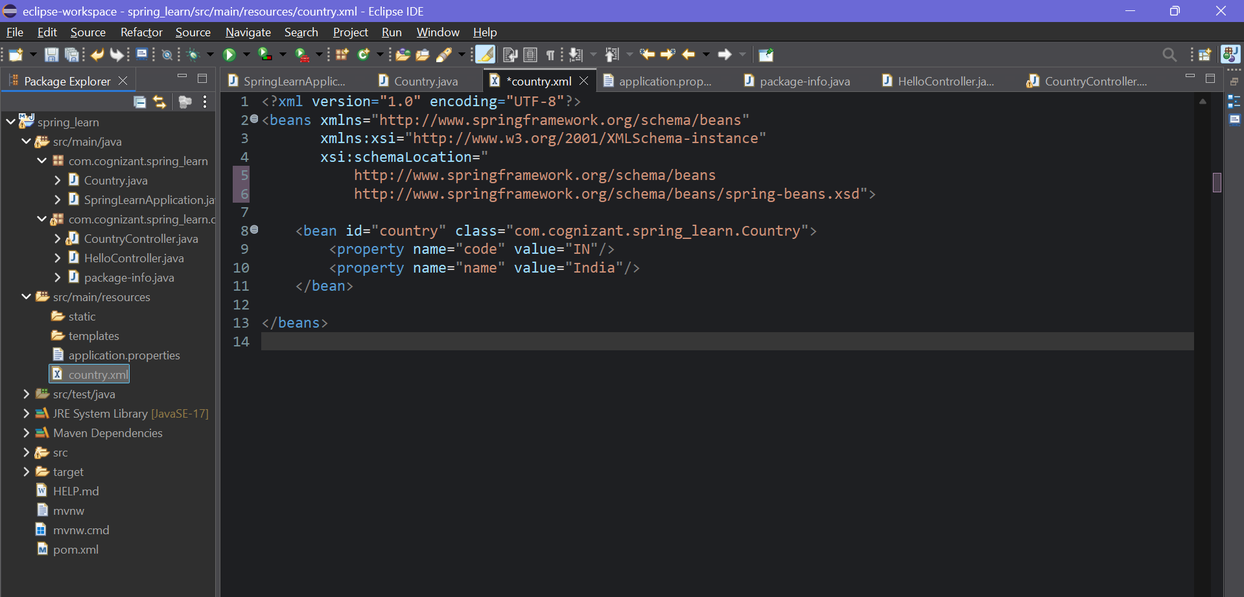

Step-2: Creating CountryController.java

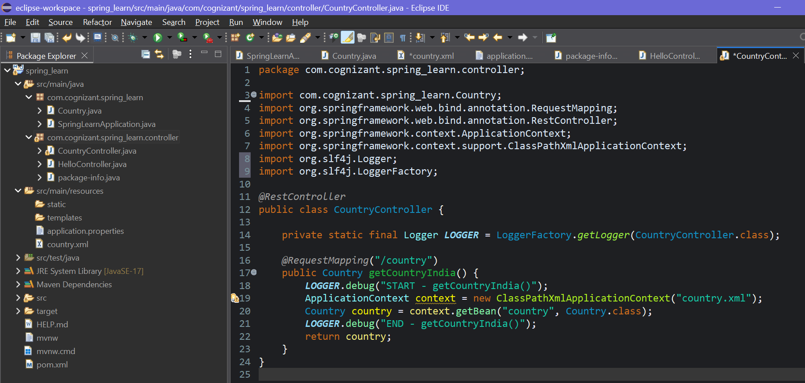

Step-3:Double checking Country.java

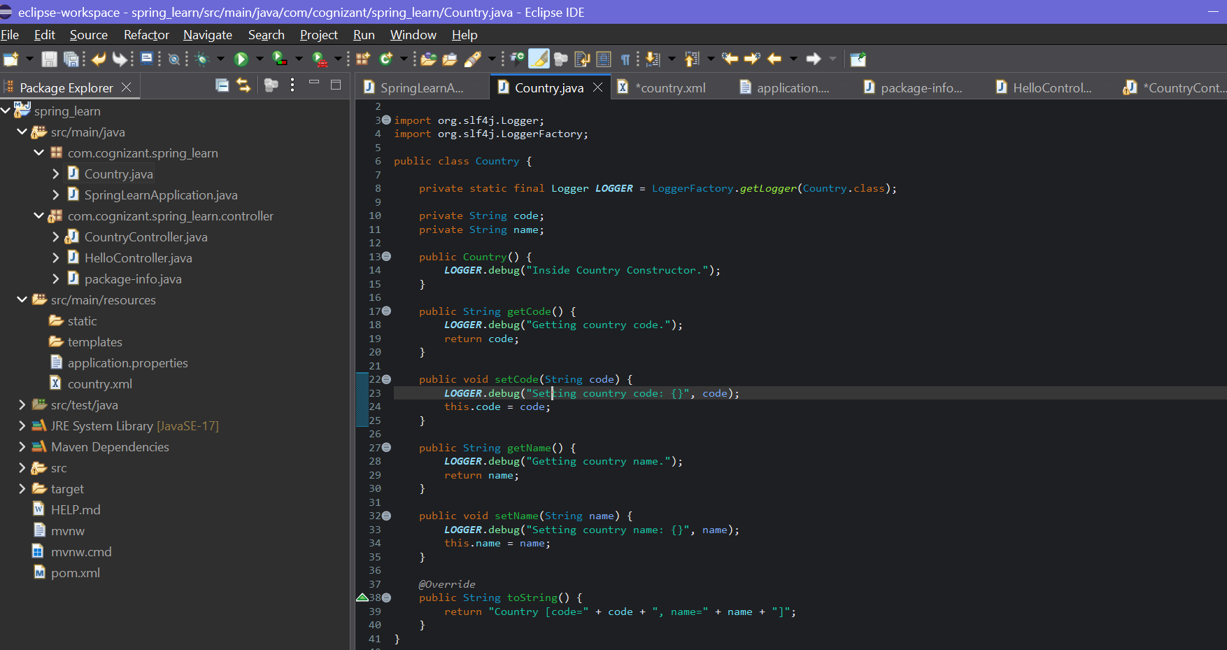

Step-4: Runing Spring Boot Application(SpringLearnApplication.java)

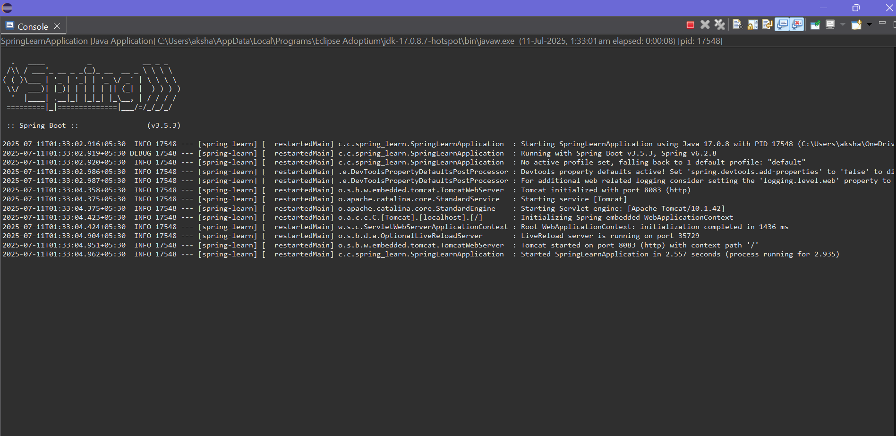

Step-5: Testing in Postman

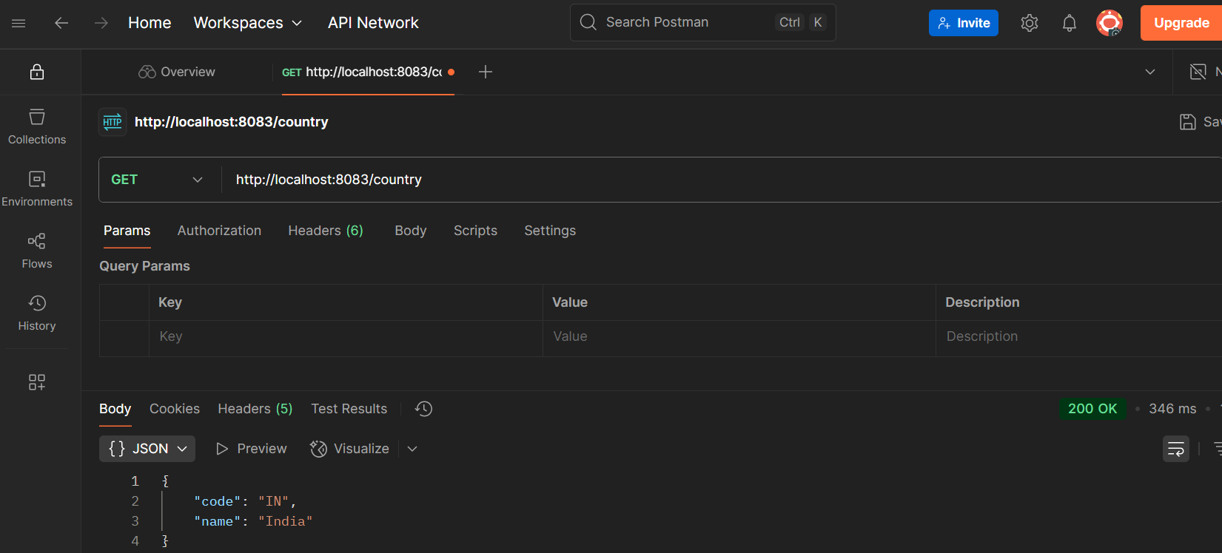

Step-6: Checking Headers(in Postman)

